Article ID: 3174
Article Name My fridge freezer does not freeze
Topic Location: Cooling/Fridge Freezer/Usage/Performance/Temperature
Meta-data: combi
Related Articles:
Related Questions:
PNC
DIY
Safety
Link
Email
X Book Engineer
Multimedia
Brand
Article Content:
The possible cause for the problem is:

Freezer function turned ON:
Make sure the freezing function is turned on and the temperature settings are correct.
Information about how to turn the freezer on and temperature settings can be found in your user instructions.

If the appliance placed in a garage, shed outbuilding or other cold environment:
See the climate classification indication on the rating plate. The proper operation can only be guaranteed for a SN-class appliance in a surrounding temperature of +10 to +32°C.
- Class N = 16-32°C
- Class SN = 10-32°C
- Class ST = 18-38°C
- Class SN/T = 10-38°C
Climate classification indication on rating plate:
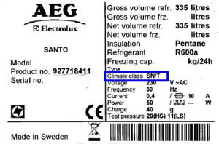
If none of the above advises solved the problem a service engineer can resolve it for you.

(Book engineer design)

